Promethus:

Errros coming when try to install with **helm**:

Iam getting the error in the creation of pods:

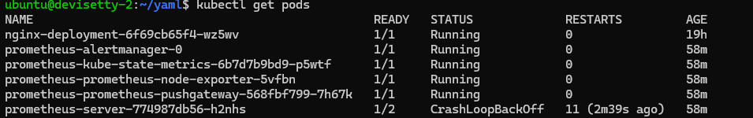

I have checked the logs

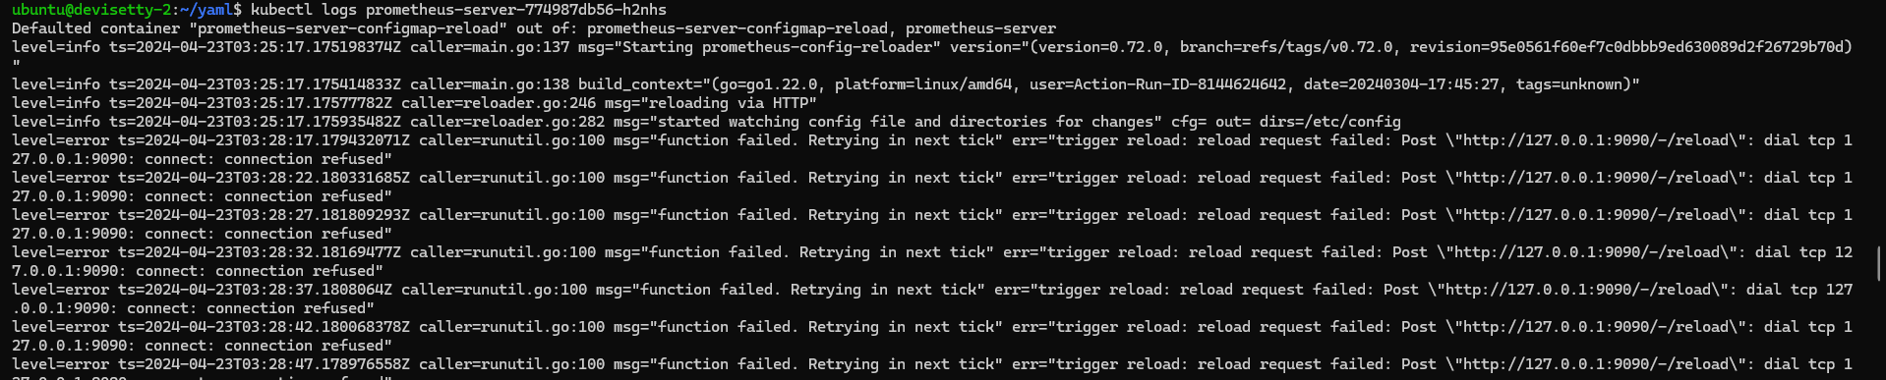

I have understood the problem is port. 9090 port problem. I have enable the port in open stack website also but also same problem.





we have enabled the all ports also in the website, but also, we are facing the same issue**. Connection refued.**

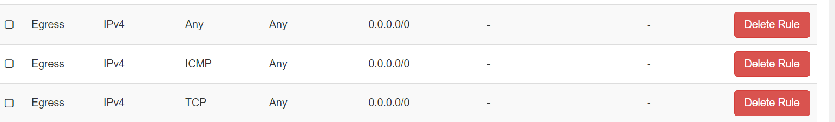

So, I decided, to install in my second vm, may be chance of working.

But also, iam facing the same issue.

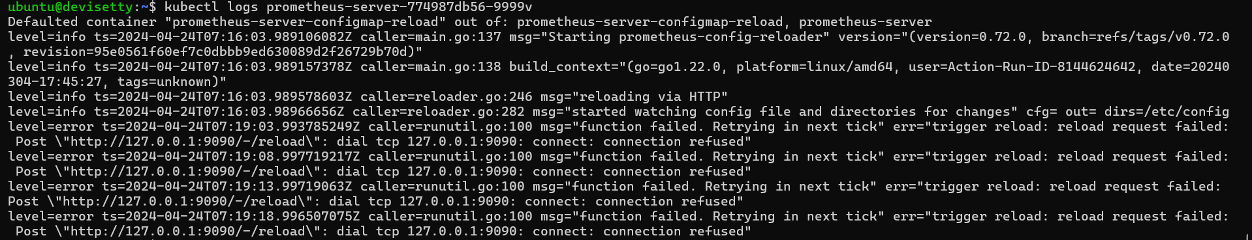

2) using yaml files

so I deleted all, this time I followed this links

<https://medium.com/@vinoji2005/install-prometheus-on-kubernetes-tutorial-and-example-6b3c800e7e1c>  
<https://medium.com/@gurpreets0610/deploy-prometheus-grafana-on-kubernetes-cluster-e8395cc16f91>

we downloaded the Prometheus, but it is not working like as expected. Not successfully downloaded.  
we need Prometheus- server and export node as pods. But they said only how to download the server. that is why we are facing this error.

3) we try to install this time from starch with out using any helm and yaml files.

<https://youtu.be/hePmCMmekmo?si=HRcfnv5RiMiepNxJ>

installed the Prometheus and graphana. But in the Prometheus when we check there is no targets atall.

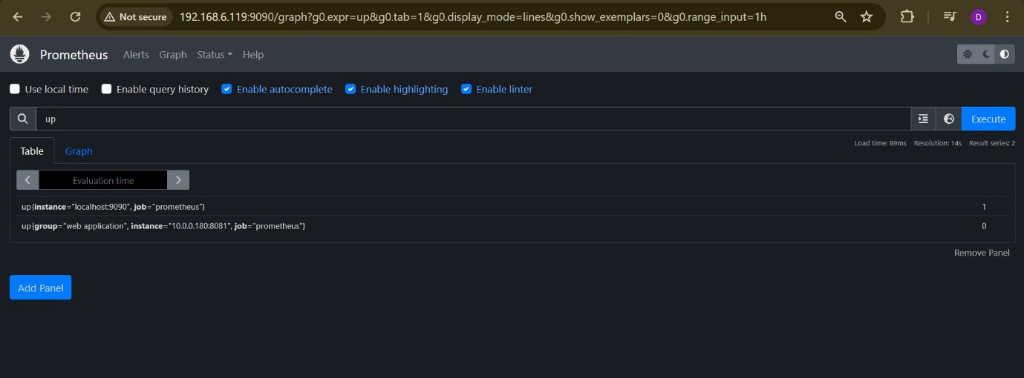

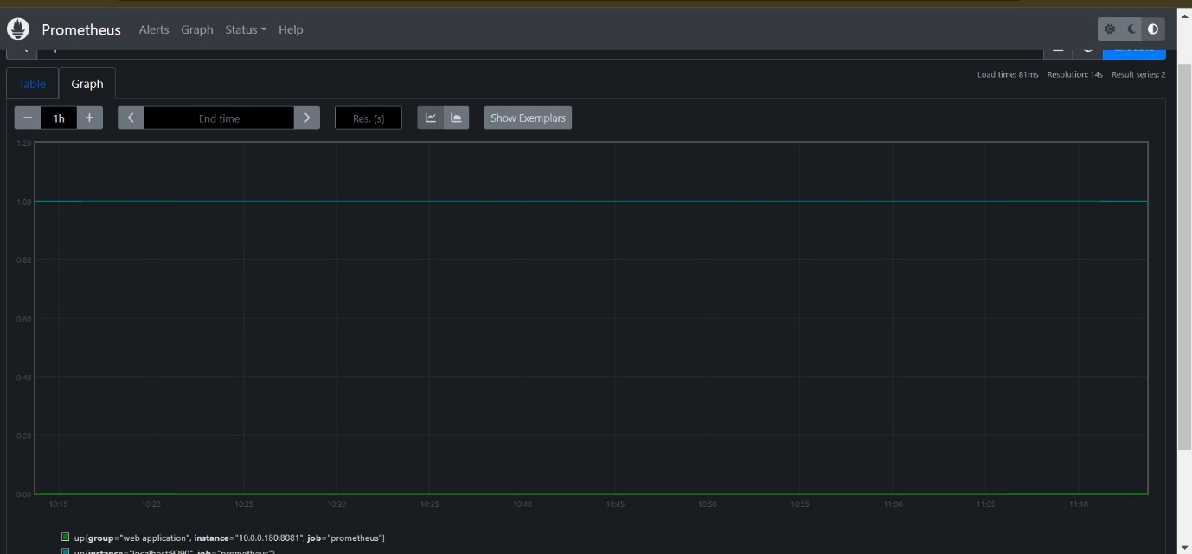

Error:

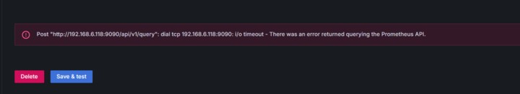

4) we are trying to install the

Successfully installed the Prometheus and Grafana.

All pods are running.

There is no problem in the service and deployment also . all are working fine,.

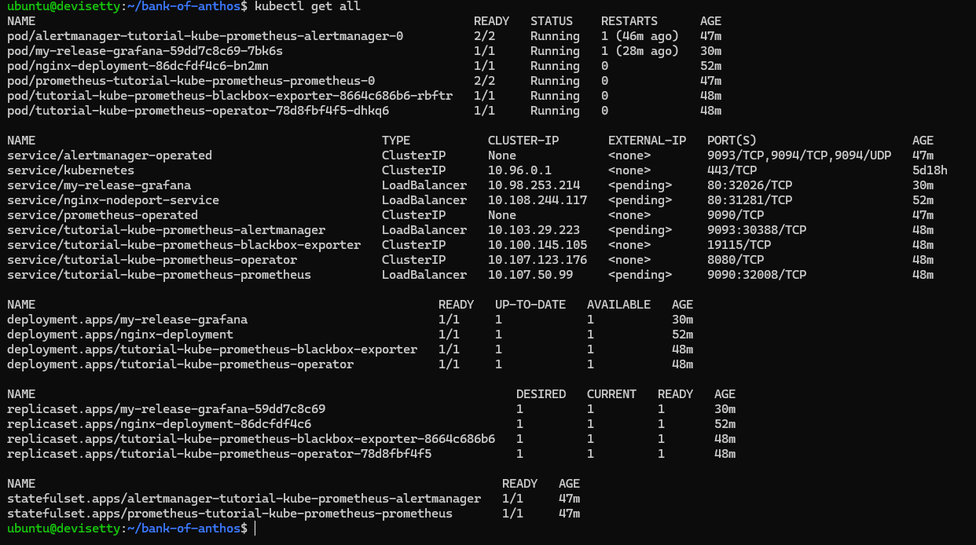

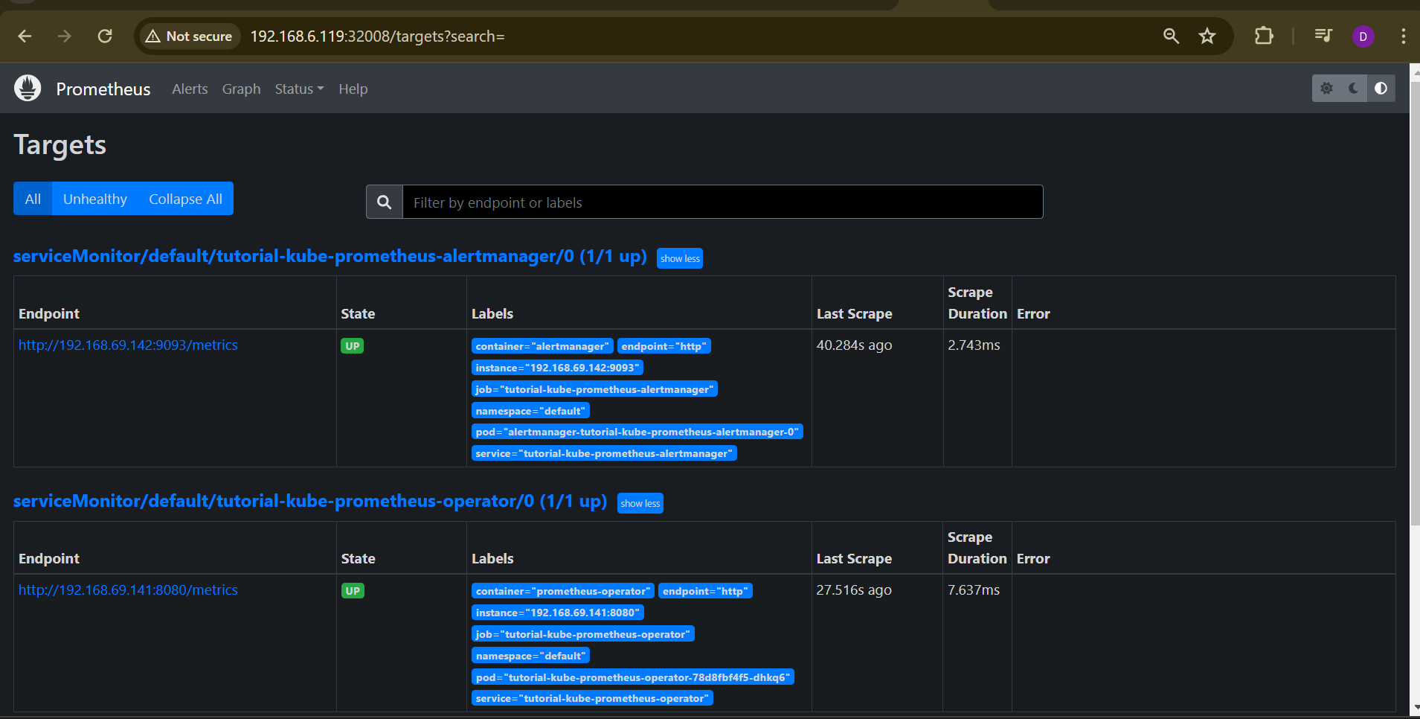

Error:

